‘SOUTH AMERICA: FROM SALT TO SILVER’
Roger Leech gave U3A members an excellent afternoon of intriguing information supported by excellent photographs of his experiences when visiting Bolivia, Chile and Peru, countries dominated by the Andes mountains. The geology, geography and culture of these fascinating countries were all covered. Having experienced both low-lying and very high terrain, Roger spoke of the range of temperatures from searingly high to extremes of cold.
Climate and geology have, in many ways, provided the foundation of life in these regions, with volcanoes and earthquakes still experienced. Amongst the highest mountains are vast areas of salt near to Cusco in Peru, around Uyuni, in the Potosi region of Bolivia and in Chile. The largest and best known of these is the Uyuni salt flat where the mineral, lithium, the power source for most of today’s batteries, is also to be found in very large quantities. There is much geothermal activity in these countries with the El Tatio geyser in Chile, one of the highest in the world, where pools can be seen steaming each morning with plumes of boiling water discharging into the surrounding pools. Hot springs can also be seen in the Atacama desert, allowing for very pleasant swimming.
Other interesting features can be seen and experienced in the Torres del Paine area of Chile with its massive spires of granite towering above the huge ice-fields and glaciers, making for an extraordinary landscape. From an ancient coral reef on the Bolivian High Plateau to its desert Hotel, the highest in the world, each of these South American countries offers a great variety of scenery, climate and wild life. By contrast, one area of Chile is known as the Lake District, and another long series of valleys in the central part of Chile with their warm, almost exotic climate are particularly renowned for their wines. Wild life is abundant in some of the lower lying areas with llamas, alpacas, vicunas and guanacos, and foxes may be seen, too.
The last part of Roger’s talk was devoted to the discovery and exploitation of silver in Bolivia, focusing on Sucre, in the limestone region and particularly on Potosi, both towns of particular significance since the 16th century when the Spanish ‘conquistadores’ discovered very large deposits of silver in the region. 1538 saw the foundation of Sucre and a few years later Potosi, at over 4,000 metres one of the highest cities in the world, was established, its mines yielding enormous quantities of silver and attracting a huge population of some 200,000. By the second half of the 16th century 60% of all silver mined in the world was mined at Potosi. Another consequence was Spain’s decision to establish a mint there in 1572 and its coins, known as ‘reales’, recognised for their particularly high silver content, were soon circulating all over the world. The historical significance of the wealth thereby generated was enormous, boosting the significance of Spain on a world-wide scale and leading to the country’s dominance for many centuries.
This most informative talk prompted a range of questions and comments, indicating that the audience had greatly enjoyed and appreciated the presentation offered by Roger Leech.
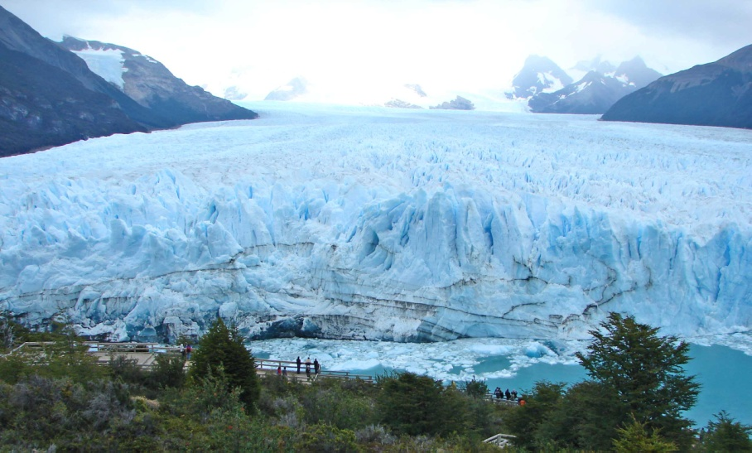

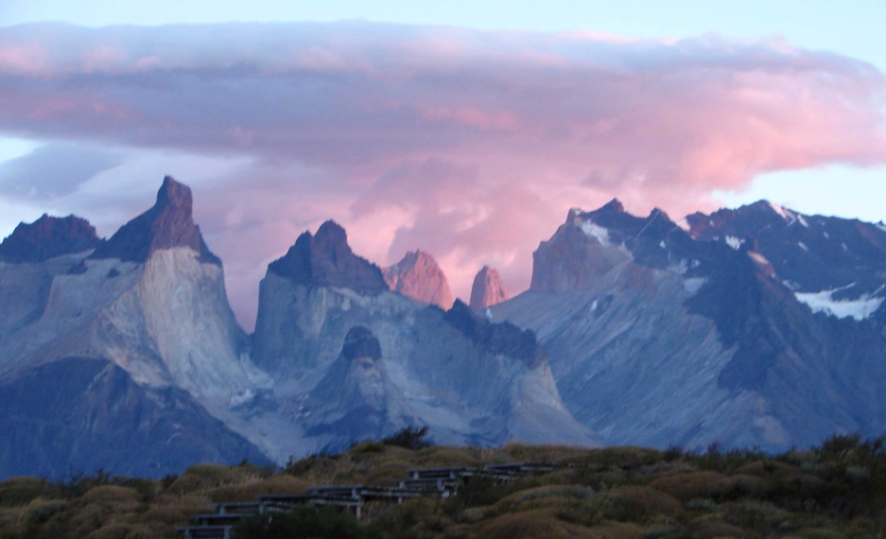

Report of Monthly meeting talk by Roger Leech, 20 January, 2022

