CHALLENGING WATERS: ‘THE DIARY OF A LAKE DISTRICT SWIMMER’
John Mather
In his recent talk to Penrith and North Lakes U3A John Mather described how, at the age of 60, he began an attempt to swim the length of the 17 “big lakes” in the Lake District which took the course of three summers. This included lakes as small as Brothers Water and as big as Windermere. The whole endeavour demanded much of John who was advised that ‘95% of the swim would require will-power and only 5% of the success would depend on his swimming ability.’ Nevertheless, the challenge proved very worthwhile and made John aware of just how beautiful and fragile the Lake District is and his talk aimed to raise our ambitions to put more than a toe in the waters of our magnificent local lakes and tarns.
John’s enthusiasm for swimming started in his youth in his local Lancashire swimming pools but the experience of outdoor swimming in unheated water required the use of some extra equipment, including a wet suit and, for safety, a colourful hat and a bright float. Unforeseen problems arose on carrying out his goal as reservoirs including Haweswater, Thirlmere and Ennerdale prohibit swimming but John came up with clever alternatives, using a rowing boat on the last two and walking round the perimeter of Haweswater. Again, Esthwaite Water is leased as a fishery, and is totally out of bounds to the public so it had to be circumnavigated on foot and at a distance from the shore. Poor weather, broken glass and polluted waters were further hazards John faced on occasions. His further experiences were, happily, to prove much more enjoyable.
John’s gentle sense of humour and the camaraderie and support of his friends, family and fellow-swimmers came across in his presentation with excellent photos illustrating the highs and lows of the whole experience. His particularly highlights were swimming the lengths of Buttermere, Rydal Water, Wastwater (despite the cold!) and Ullswater, each in good weather, and each lake with clear, unpolluted water and surrounded by wonderful scenery. Sometimes friends swam along with John, on other occasions, from a boat, they plied him with Mars bars to keep up his energy levels. It took 3 swims to complete the full length of Windermere which is over 10 miles long but he persisted.
The whole endeavour provided many positive memories as John’s photos proved: the delights of swimming under a blue sky below the grandeur of fells such as Skiddaw, Scafell Pike, Helvellyn and the peaks surrounding Buttermere and Crummock Water were wonderful experiences. For those keen to take up significant outdoor swimming endeavours, John advised doing some preliminary training and checking out any medical problems which might compromise them. Hopefully more will join those who have already discovered the delights of swimming in the clear, refreshing waters of our own local lakes and tarns even if they do not achieve the 40 miles of unassisted swimming required to match John Mather’s challenge.
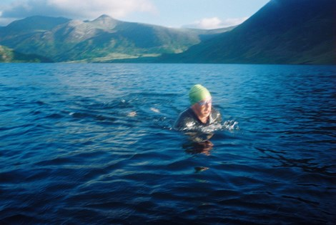
John Mather swimming Ullswater

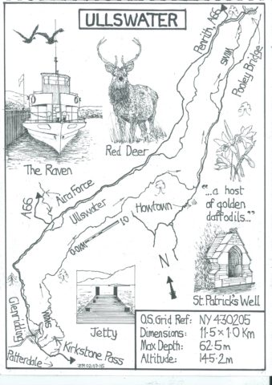
An illustration from his book: ‘Challenging Waters’

