THE TRUE HISTORY BEHIND VIKING VOICES

PAUL ATHERTON

An accomplished speaker and writer, Paul Atherton gave a very interesting talk to the Penrith and North Lakes U3A recently. In his determination to write a novel, he chose a subject of particular interest and first did a significant amount of historical research into the Vikings and their settlements in various parts of Britain between the 8th and 11th centuries. By way of introduction, Paul referred to the survey conducted 20 years ago involving blood sampling which revealed that, outside the far north of Scotland, Penrith was the only place clearly showing that the Norwegian Vikings had settled. Using a range of photos of artefacts and a map identifying where they chose to stay, Paul gave us an intriguing picture of the complex network of towns and villages established in Scotland, England, Wales and Ireland by the various groups of Vikings from Denmark, Norway, and other parts of Scandinavia.

This was the background for the Paul Atherton’s novel, ‘Viking Voices’, based on true events that led to the Cuerdale Hoard’s burial in the banks of the River Ribble around 905 AD and discovered in 1840. It is now in the British Museum. Comprising some 8,600 pieces of silver and weighing about 63 pounds, this is the largest hoard ever found in Western Europe, only a couple of ounces short of the heaviest ever discovered. It is made up of Viking silver in the form of coins, ingots, brooches and hacksilver. Paul’s novel follows the adventures of a fictitious married couple who are part of a group of Norse expelled from Dublin seeking to reclaim their home from the Irish tribes. The main characters are fictional but the events they are caught up in are actual events.

Altogether it was a very interesting talk, leading members of U3A to delve more deeply in the historical and archaeological evidence of the Viking settlers in Britain.

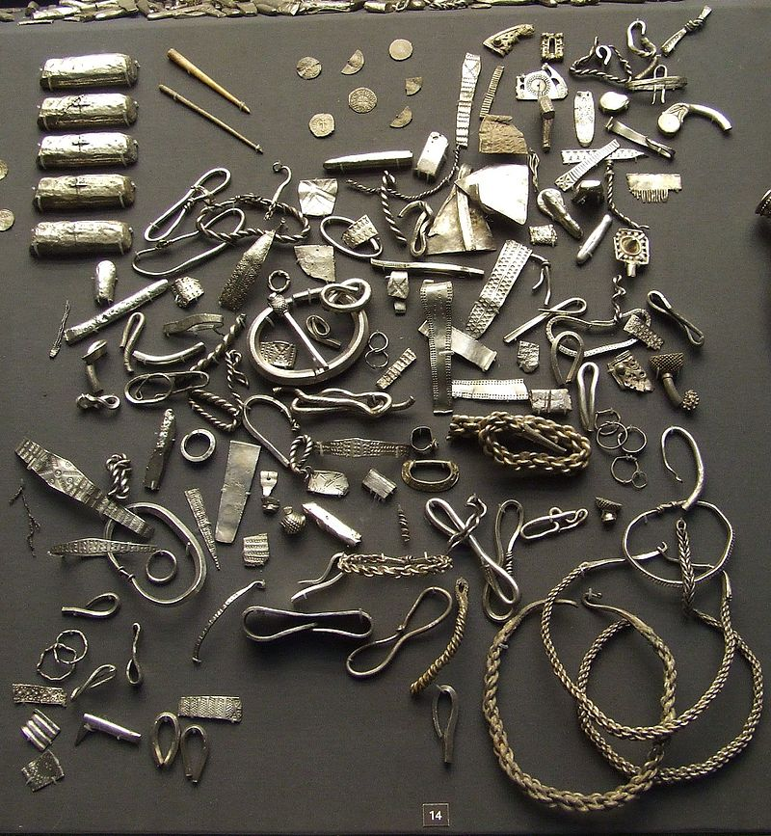
The Cuerdale hoard is now in the British Museum
